2022

Radu Popescu

Fontys University of Applied Sciences

19/12/2022

RobertHeijn B.V. Project Plan

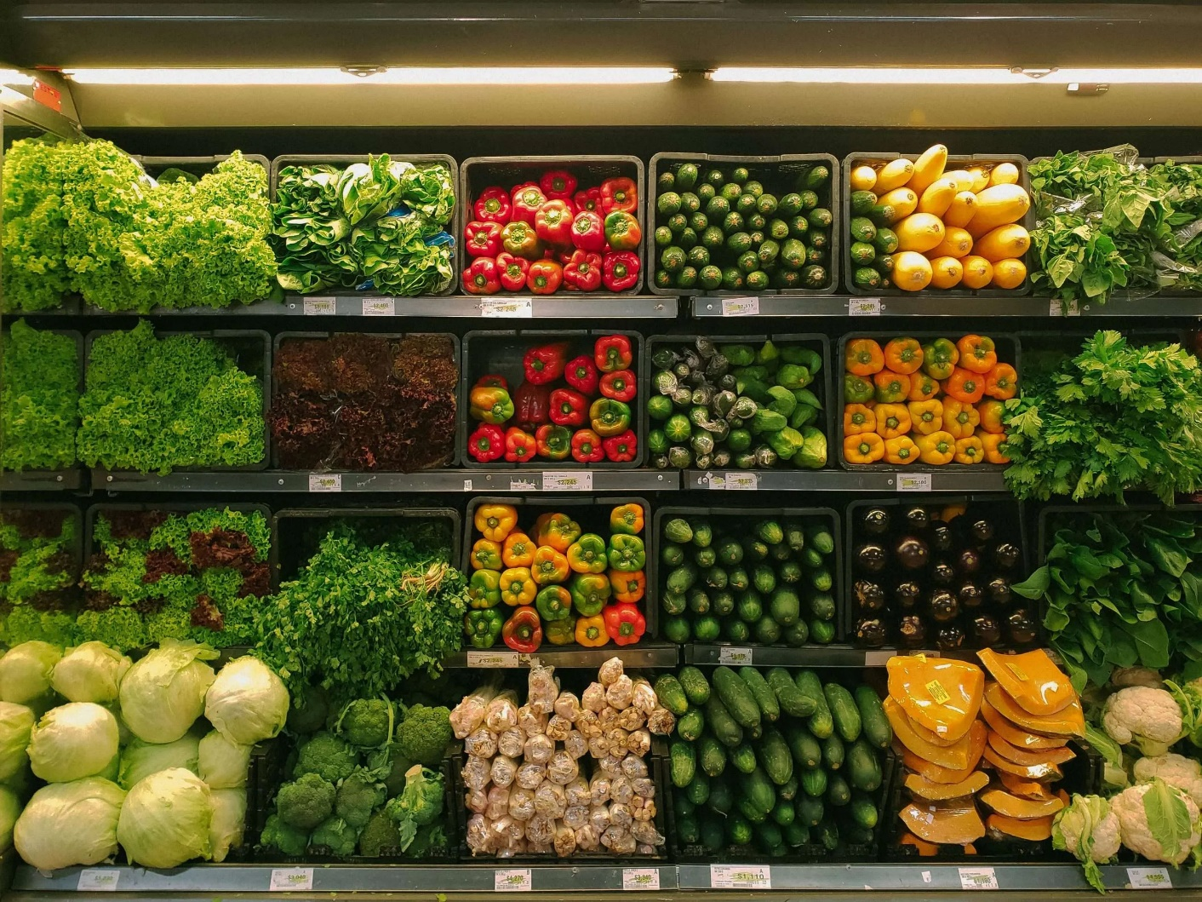

Contents

About Me 2

Client Description 2

Current Situation 2

Problem Statement 2

Project Goal 2

Deliverables and non-deliverables 3

Project Constraints 3

Phasing 3

# About Me

My name is Radu Andrei Popescu, I am a student at Fontys University of Applied Sciences and I study ICT & Communication. I can be contacted at the email address [raduandrei.popescu@student.fontys.nl](mailto:raduandrei.popescu@student.fontys.nl) or at the phone number +40722383405. Should I not be available by any f those I can be found at the Fontys University R10 building on Rachelsmolen 1.

# Client Description

The Client for this project is the widely known company as RobertHeijn B.V. They have contacted me in regards to the issue of an application that would allow the clients of the supermarket to shop online. My contact for RobertHeijn B.V is Chua Jessie and I can contact her at [j.chua@fontys.nl](mailto:j.chua@fontys.nl). She will guide me through this project and oversee the development of the application.

# Current Situation

RobertHeijn B.V. currently does not have an application that allows the customers to order and shop online and one that allows the employees to manage the orders and requests. They only have a physical shop, but not an online one.

# Problem Statement

One of the problems that RobertHeijn faces is the monitoring of their employees and products data. Since RobertHeijn B.V manages and supplies thousands of products to their customers it has become almost impossible to keep track of them all on paper.

They also manage every order they receive and since they do not possess a digital system that can easily store and keep track of every order a lot of customers have either not received their order or it has arrived incomplete or late, which has become a problem for their customer service.

For this reason, their clientele has plummeted along with the rise of a lot of negative reviews to their services.

# Project Goal

My project is intended to provide a maintainable and secure solution to the issues stated above that the RobertHeijn B.V. faces. The Desktop application should prove understandable by any employee. Its main purpose is the managing the product data and easy editing and viewing of it. It should also allow the employees to keep track of the orders and allow the marketing department to show bonuses and discounts on their website.

As for the website, it will allow the customers to view the catalogue of products that RobertHeijn possesses and shop online. It will also allow them to create accounts and add products as favourites.

This project should contribute in the long term to the better workflow and the administration of the supermarket.

# Deliverables and non-deliverables

We have identified a total of 10 types of deliverables to the client, these are:

* Agenda’s & minutes of every meeting
* Project plan
* User Requirements Specification document (URS)
* UML class diagram
* Desktop Application source code and binaries
* Website Application source code and binaries
* Test plan with Test Report

As for the non-deliverables, I will not provide:

* Hardware for the applications (Laptops, Computers)
* Training
* Manuals and installation services

# Project Constraints

The project should be coded in the programming language C# with Windows Forms and ASP.Net Core Razor Pages frameworks. For the website part a layout framework such as Bootstarp is required along with the use of a MySQL or MSSQL database.

Both the software for the website andthe desktop application is required to be able to handle fake data for the testing of its algorithms.

The UX of both applications should follow the common practices (e.g., intuitive design, understandable and easy to use interface) and feedback received from the client.

Meetings with the client should be weekly and not missed.

Final submission should be before 16:00 on 23rd of December.

# Phasing

This is the plan that I made having in mind the total of 6 weeks of work:

The first two weeks are crucial since they will include the necessary documents to lay out the general plan of the project along with the design and first version of the application. The following weeks I will continue with the rest of the features and the website and the last weeks target is to add the finishing touches along with bug testing and reports.

To accommodate the client as much as possible, I will dedicate most, if not all of my time to this project, which is 5 hours per day which amounts to a total of 200 hours.

The following Gantt chart was made to visualize the phasing and course that I will be taking in order to achieve the desired end product.

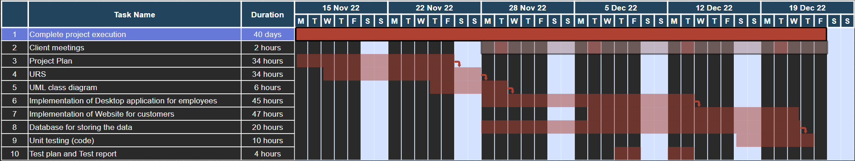

Should there be any interfering that could disrupt the workflow of the project, the client will be contacted immediately to find a suitable mitigation.